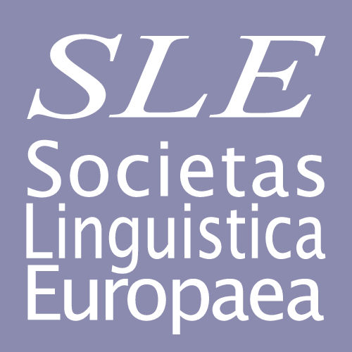

Andreas Schelfhoutstraat 31 H, 1058 HR Amsterdam, Netherlands

Secretary: Bert Cornillie sle@kuleuven.be
Treasurer: Lachlan Mackenzie TreasurerSLE@gmail.com

MEMBERSHIP RENEWAL FORM
I would like to renew my membership of SLE.

In SLE’s files I would like to be listed as follows (please note that the e-mail address you specify here should be used for all contacts with SLE):

TITLE:
NAME:
E-MAIL ADDRESS:
UNIVERSITY:
DEPARTMENT:
ADDRESS:
TOWN:
POST CODE:
COUNTRY:
TELEPHONE:

The membership fee is €30 p.a. for employed members, €15 p.a. for undergraduate, Master’s and PhD students without salary or retired colleagues, and €10 p.a. for members from economically challenged countries.* Non-student members who pay three years in advance may apply the reduced rate of €75.

* Currently these countries are:

Albania, Algeria, Argentina, Armenia, Belarus, Bosnia, Brazil, Bulgaria, PR China, Costa Rica, Croatia, Ecuador, Georgia, India, Indonesia, Iran, Macedonia, Mexico, Moldova, Nepal, Pakistan, Philippines, Romania, Russia, Serbia, Togo, Turkey, Ukraine, Venezuela, and a series of other countries. This list is based on current membership. If you think your country might belong to this category, please contact the treasurer at TreasurerSLE@gmail.com

□ I have transmitted the sum of € ….. to Societas Linguistica Europaea, account number
65.31.39.519 at ING Bank, Amstelveenseweg 500, 1081 KL Amsterdam, Netherlands

BIC: INGBNL2A
IBAN: NL76 INGB 0653 1395 19

Please send this form to TreasurerSLE@gmail.com

Date:

Signature:

