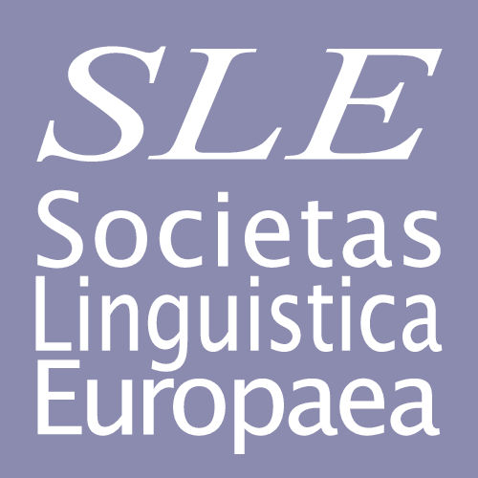

Andreas Schelfhoutstraat 31 H, 1058 HR Amsterdam, Netherlands

Secretary: Bert Cornillie sle@kuleuven.be
Treasurer: Lachlan Mackenzie TreasurerSLE@gmail.com

APPLICATION FORM
I would like to become a member of SLE. My membership is to begin in the year ................

In SLE’s files I would like to be listed as follows (please note that the e-mail address you specify here should be used for all contacts with SLE):

TITLE:
NAME:
E-MAIL ADDRESS:
UNIVERSITY:
DEPARTMENT:
ADDRESS:
TOWN:
POST CODE:
COUNTRY:
TELEPHONE:

The membership fee is €30 p.a. for employed members, €15 p.a. for undergraduate, Master’s and PhD students or unemployed or retired colleagues, and €10 p.a. for members from countries whose per capita nominal GDP (accordingly to the latest IMF data) lies below $20,000.* Employed members who pay three years in advance may apply the reduced rate of €75.

*These countries currently include:

Albania, Algeria, Argentina, Armenia, Belarus, Bosnia, Brazil, Bulgaria, PR China, Costa Rica, Croatia, Ecuador, Georgia, Greece, Hungary, India, Indonesia, Iran, Latvia, Lithuania, Mexico, Moldova, Nepal, North Macedonia, Pakistan, Philippines, Poland, Romania, Russia, Serbia, Slovakia, Togo, Turkey, Ukraine and Venezuela. If you think your country might belong to this category, please contact the treasurer at TreasurerSLE@gmail.com

□ I have transferred the sum of € ….. to Societas Linguistica Europaea, account number
65.31.39.519 at ING Bank, Amstelveenseweg 500, 1081 KL Amsterdam, Netherlands

BIC: INGBNL2A
IBAN: NL76 INGB 0653 1395 19

Please send this form to TreasurerSLE@gmail.com

Date:

Signature:

